Setting Up Application Environment

|  |  |
| --- | --- |
| **Date** | 31October 2022 |
| **Team ID** | PNT2022TMID106311 |
| **Project Name** | Pharmacy Management System |

Flask Project:

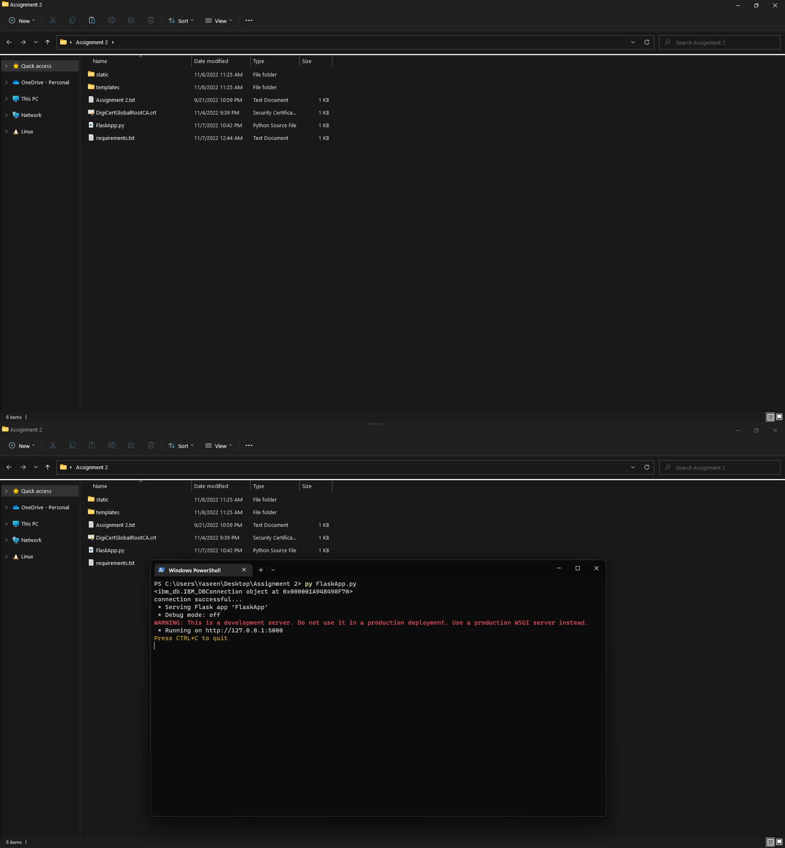

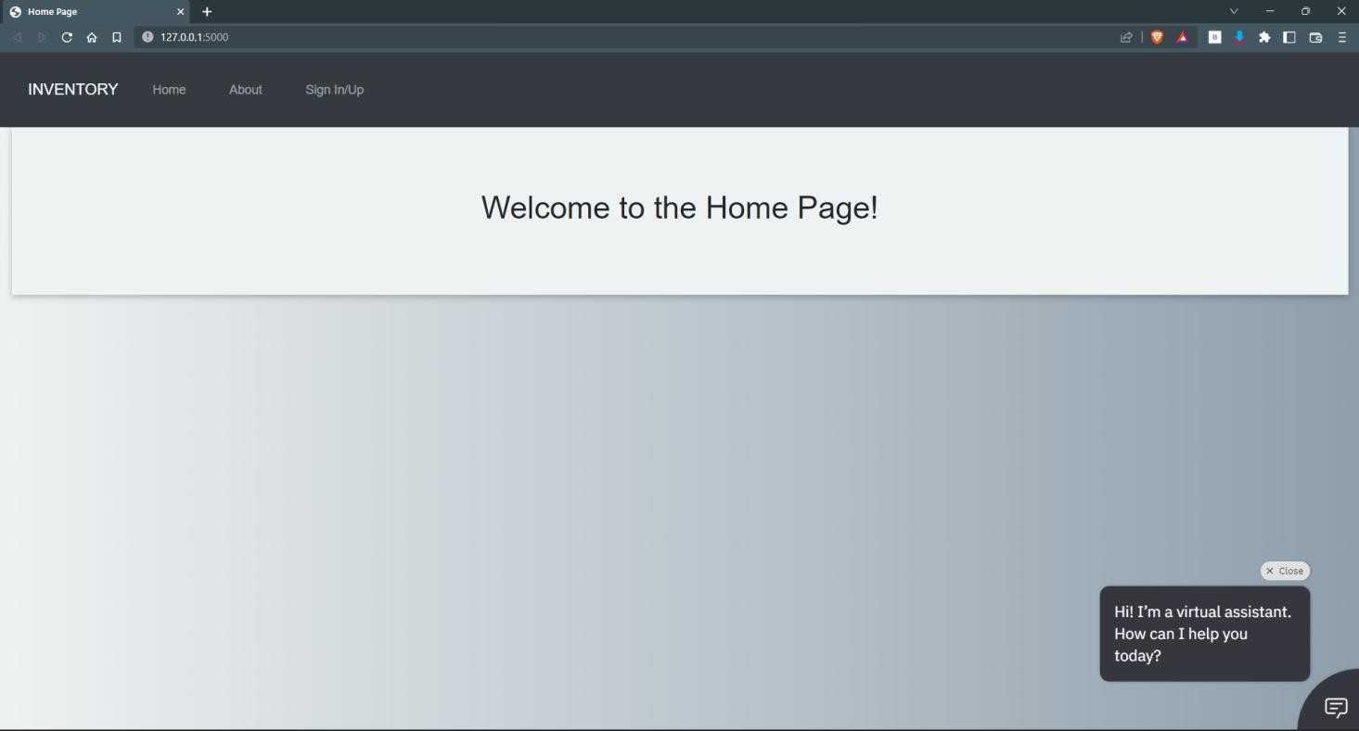

Create IBM Cloud Account:

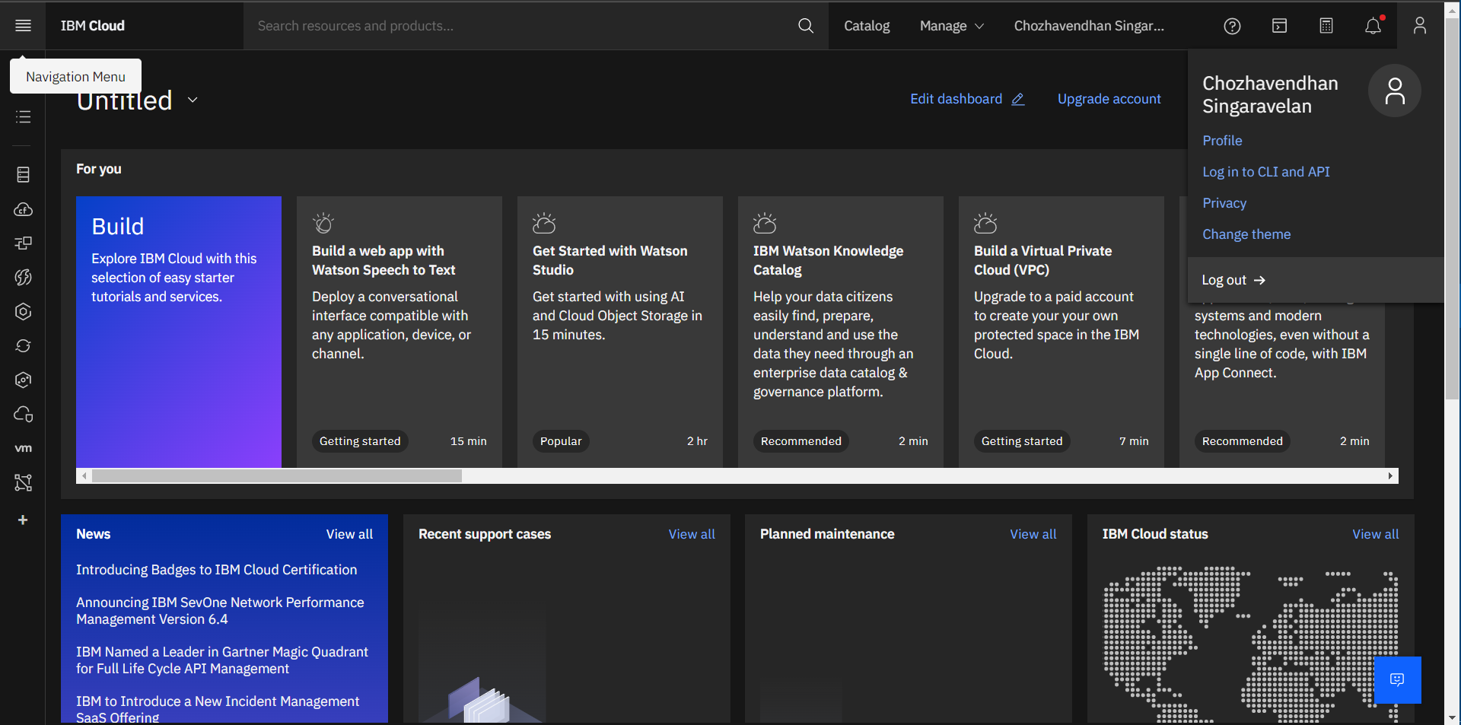

Install IBM Cloud CLI:

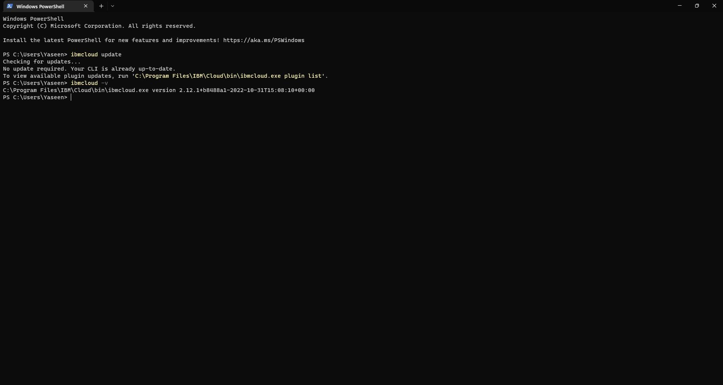

Docker Setup:

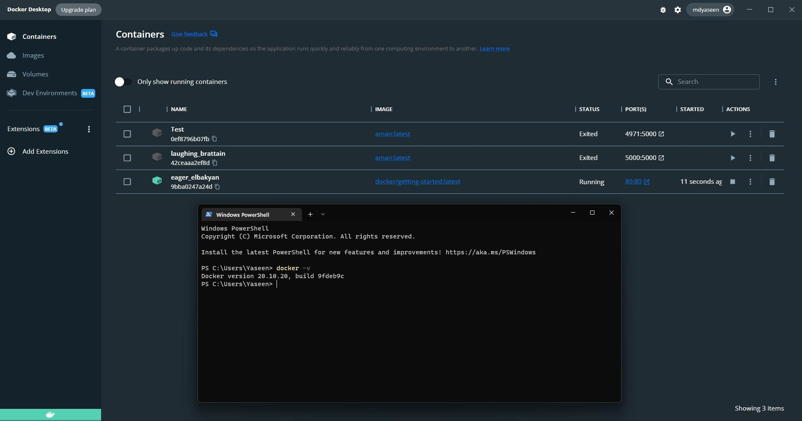

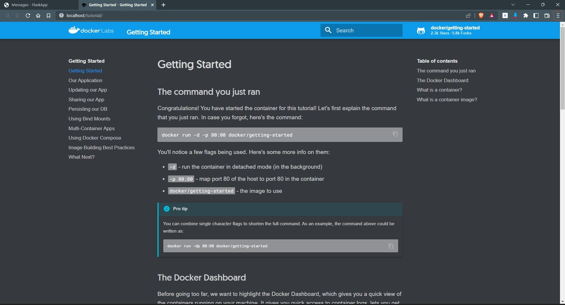

Create an account in SendGrid:

